Ex2 - Attaching AWS EBS volume to Amazon EC2.

# Nithin Prasath C – 22BCS081

## AIM:

To attach AWS EBS volume to Amazon EC2.

## DESCRIPTION:

Attaching an AWS EBS volume to an EC2 instance involves creating a volume in the same availability zone, then linking it to the desired instance. This process allows the instance to utilize additional storage for data persistence. Once attached, the volume can be formatted and mounted within the instance's operating system, providing extra space for applications and data storage.

## OUTPUT:

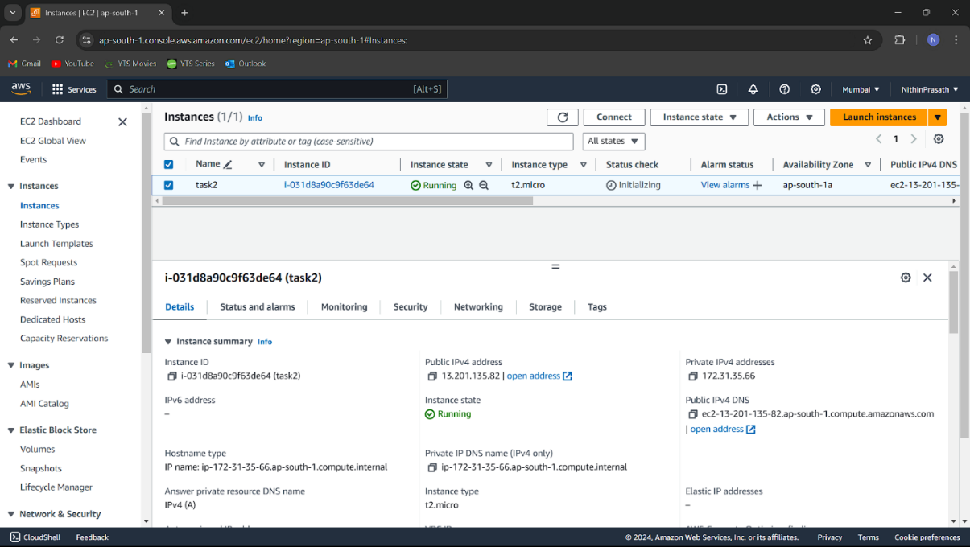

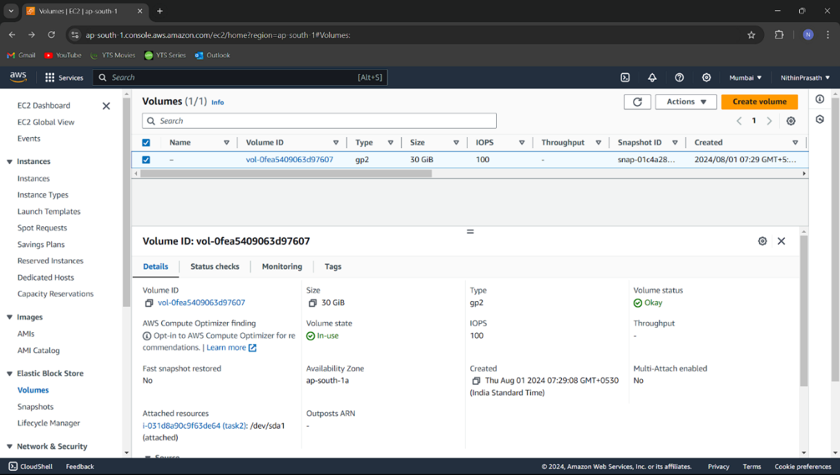

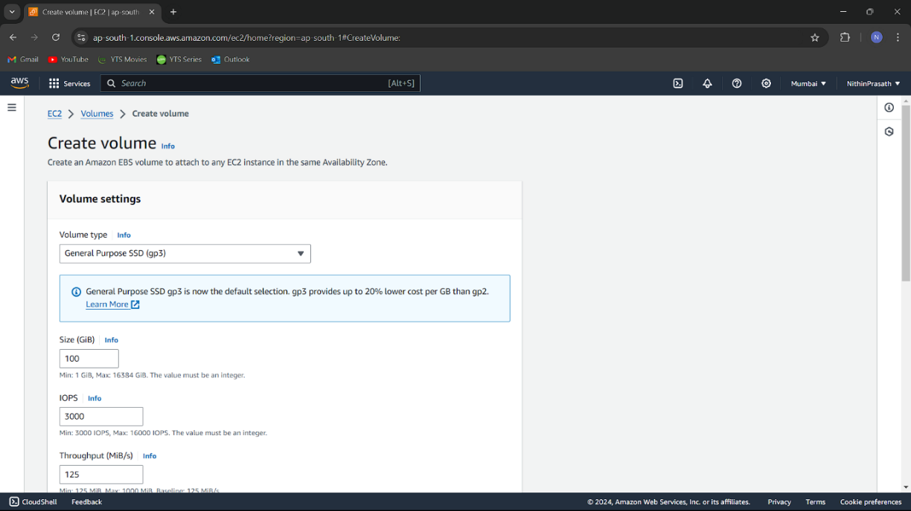

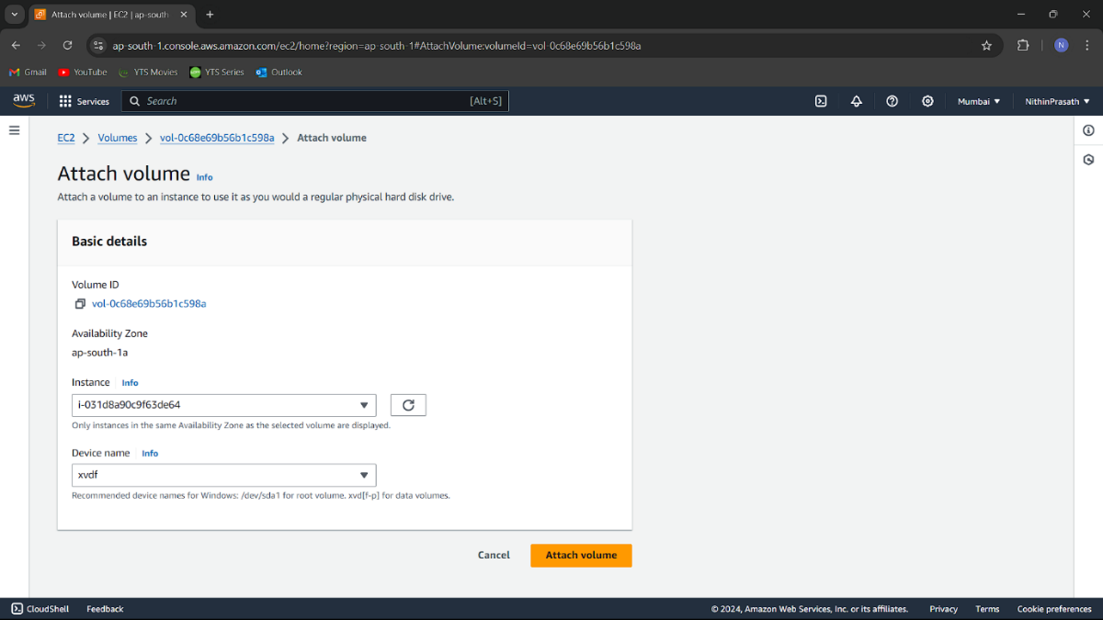

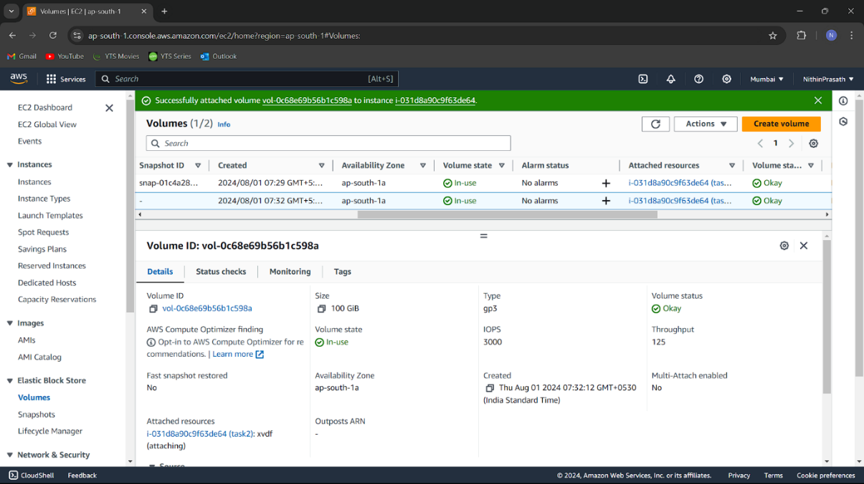

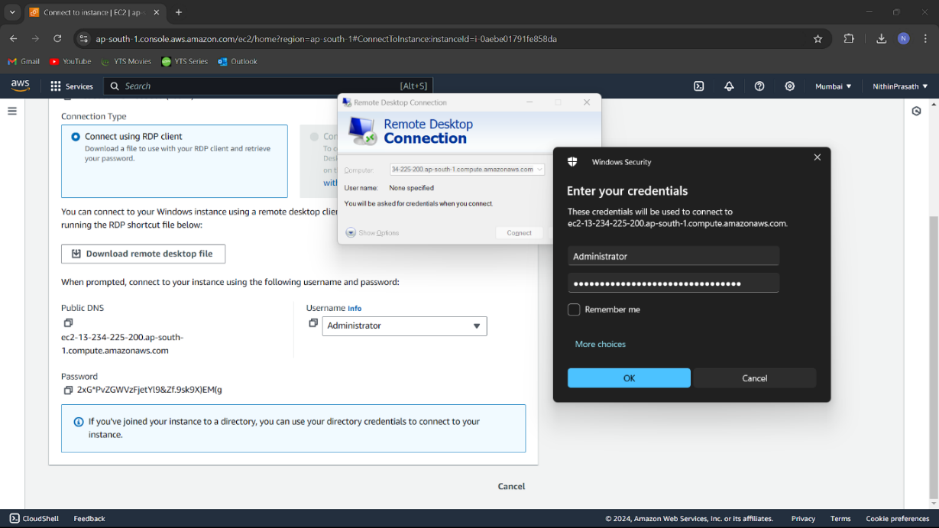

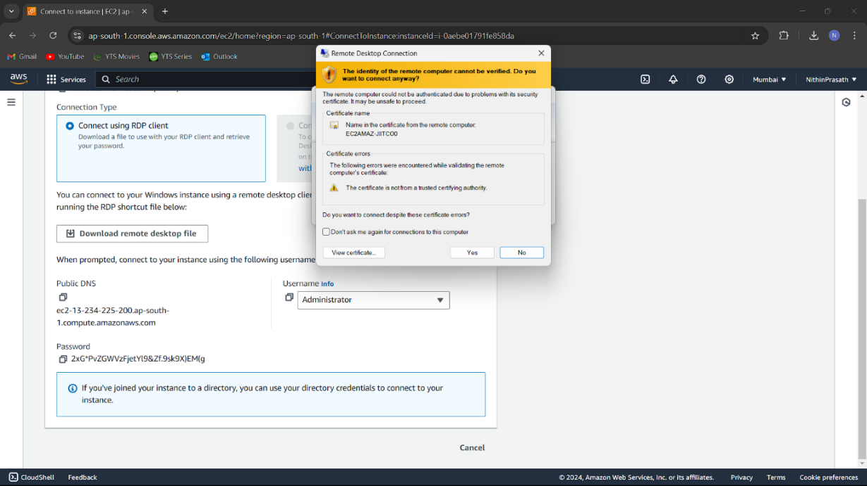

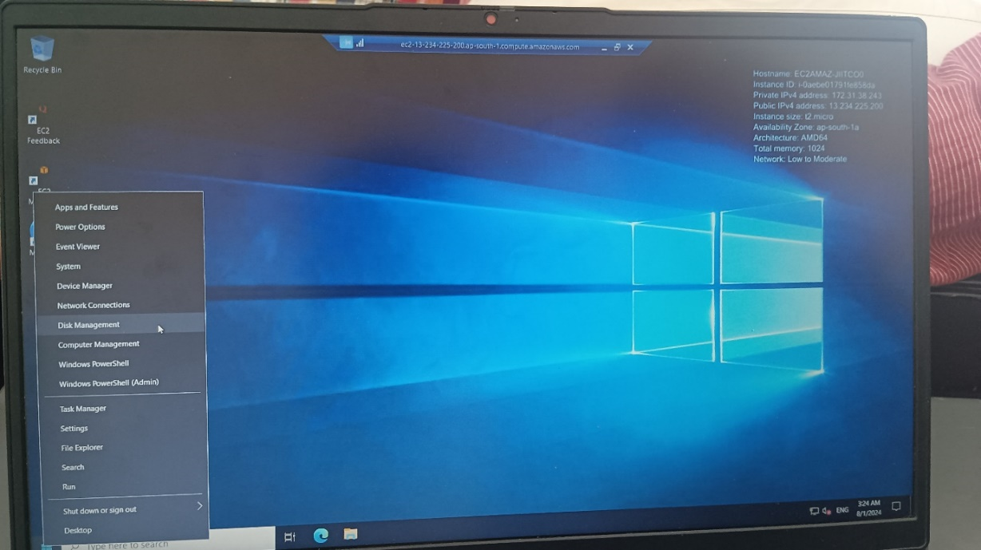

### Result**:**

Successfully attached AWS EBS volume to Amazon EC2. The instance is now running and accessible. Screenshots are attached to demonstrate each step.